

|  |  |
| --- | --- |
| **Name: Sayyed Sohail Rashid** | **Course Name: SMA-LAB** |
| **Class: BE-CO** | **Batch: 01** |
| **Roll no: 18CO48** | **Experiment No: 01** |

**Aim**: Study various social media platforms and their analytics tools.

**Theory:**

1. Social Media platforms (Facebook, Twitter, YouTube, etc.)
   * Social media are interactive technologies that facilitate the creation and sharing ofinformation, ideas, interests, and other forms of expression through virtual communities and networks.
   * The term social in regard to media suggests that platforms are user-centric and enablecommunal activity. As such, social media can be viewed as online facilitators or enhancers of human networks—webs of individuals who enhance social connectivity. ● Some very famous Social Media platforms are Facebook, Twitter, YouTube, etc. ●Establishing a presence on such social platforms is now a necessity for successful businesses.
   * Some benefits of social networking platforms in marketing are:
     1. Builds Brand Awareness and Recognition

○ Generates Conversation Around Your Brand

○ Helps Understand Your Target Customers’ Interests

○ Provides Platforms to Tell Your Brand’s Story

○ Helps You Gather Data About Your Audience

○ Helps Provide Responsive Customer Service

○ Helps Build Customer Loyalty

○ Helps Drive Traffic to Your Website

○ Tweets Can Show Up in Google Searches

○ Helps Identify and Connect With Potential Business Partners and Collaborators

○ Makes It Easy to Distribute Content

○ Helps You Stay Current With Industry News

○ Can Help You Identify Trends in Consumer Behavior and Opinions ○ Can Help You Do Competitor Research

* + For example
    1. Facebook is an online social media and social networking service owned by American company Meta Platforms.

○ Twitter is an American social media company based in San Francisco,

California. The company operates the microblogging and social networking service Twitter.

○ YouTube has had an unprecedented social impact, influencing popular culture, internet trends, and creating multimillionaire celebrities.

○ Instagram is a photo and video sharing social networking service. The app allows users to upload media that can be edited with filters and organized by hashtags and geographical tagging.

1. Social Media analytics tools (Facebook insights, google analytics, netlytic,etc.) **●**

**Google analytics**

Google Analytics is a Tracking Platform that monitors and records what people do on a website or a social network. Google Analytics stores the activities of web and app users, and it reports these activities comprehensively in an organized form to help businesses make smarter decisions. By extension, this service gives business owners the tools they need to get their business results with their Marketing Strategies – all in one place! Key Features of Google Analytics

○ Google Analytics tracks Website Traffic, its sources, frequency, and pages visited.

○ It measures user behavior through their activities like keywords and preferences.

○ It helps you monitor your Marketing Performance.

○ It gives web customizable metrics and audience data.

○ It enables the user to visualize web and app data.

○ It provides data-powered insights into the effectiveness of your marketing strategies.

Some Analytics that can be performed are shown below:

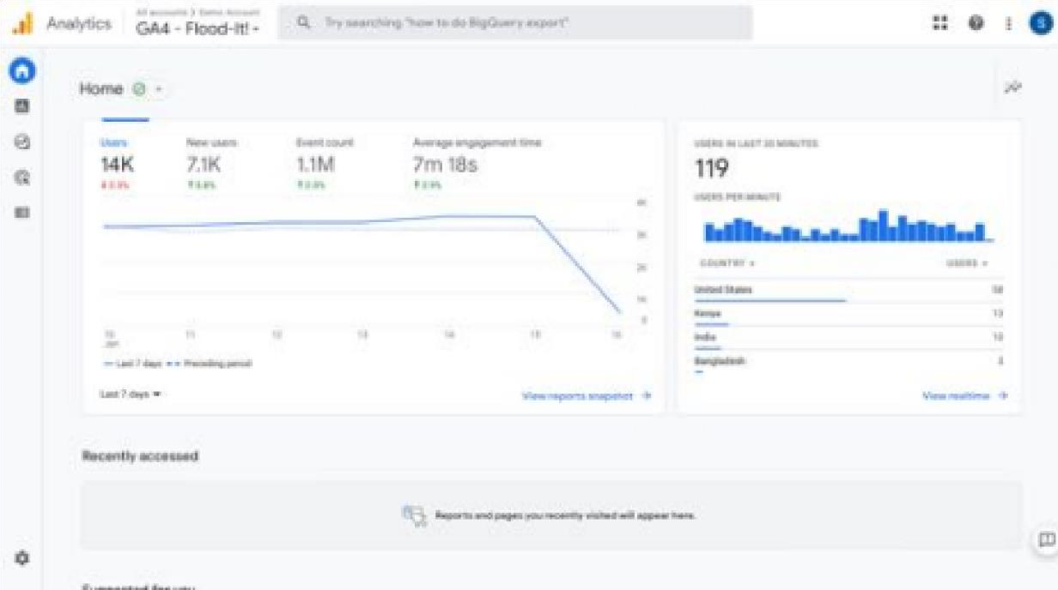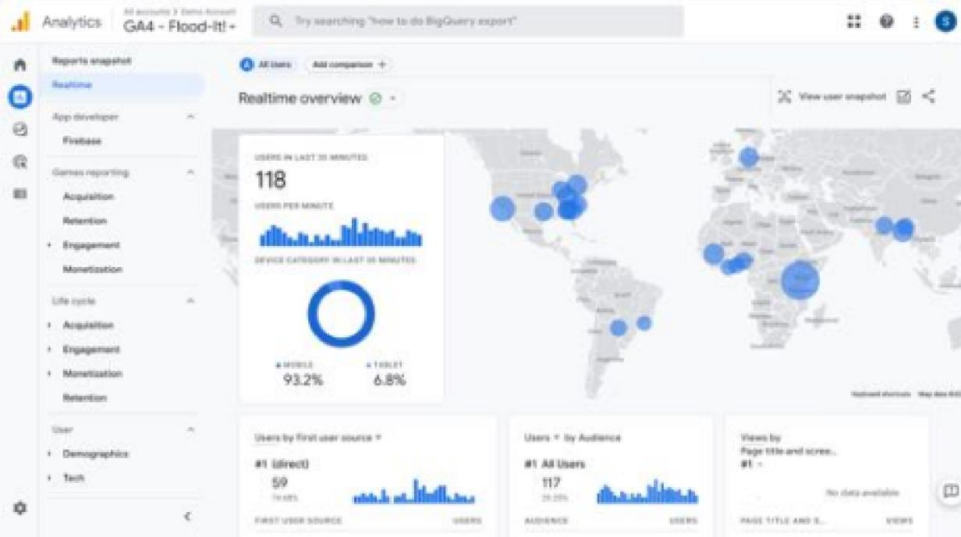

**● Facebook Insights**

○ 2.11 billion individuals are potentially reachable through Facebook advertising.

○ Facebook has over 10 million active advertisers as of 2023.

○ 34.1% of adults worldwide over the age of 13 see Facebook advertisements.

○ 63.7% of Americans over the age of 13 are exposed to Facebook ads.

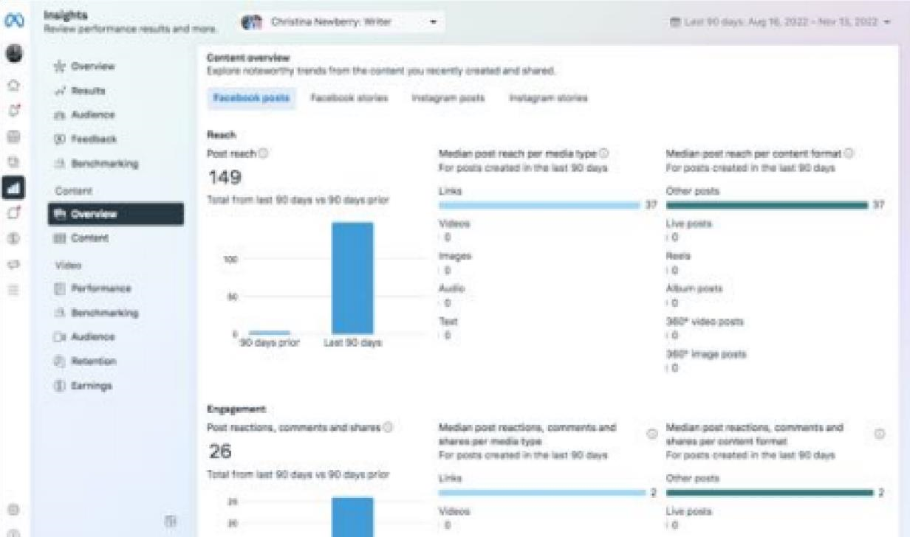

* **Netlytic**

Netlytic is a community-supported text and social networks analyzer that can automatically summarize and visualize public online conversations on social media sites. It is made for researchers by researchers, no programming/API skills required.

Key Features of Netlytic

* Capture publicly available posts from social media sites or other sources

(Twitter,YouTube, RSS Feed, or text/csv file)

* Discover popular topics
* Find and explore emerging themes of discussions
* Build, visualize and analyze online communication networks using social networkanalysis
* Map geo-coded social media data

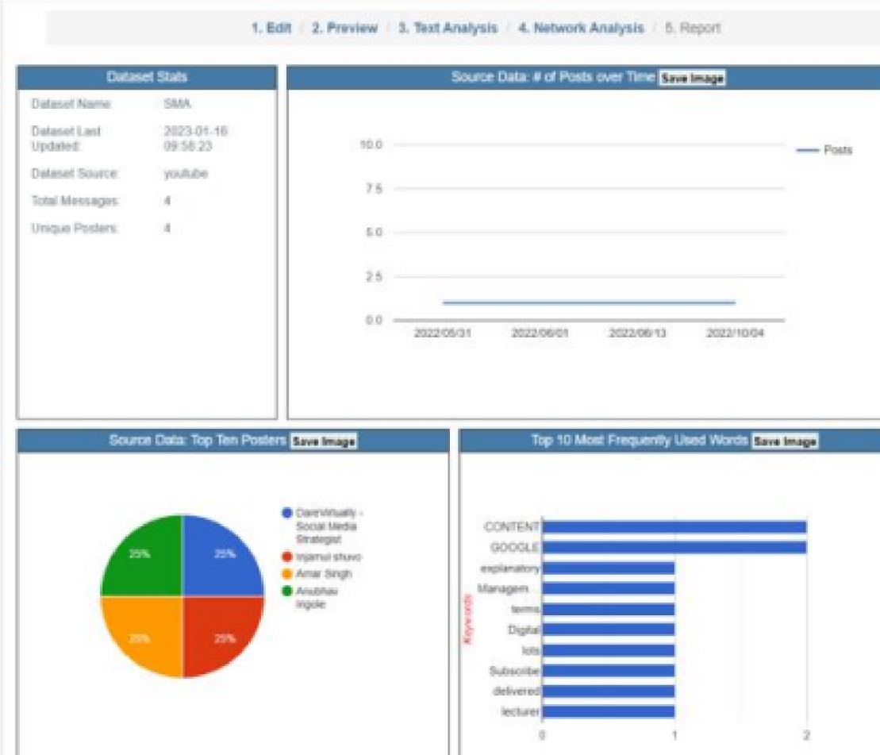

iii) Social Media Analytics techniques and engagement metrics (page level, post level, member level)

● **Post-level Metrics**

Post-level metrics display lifetime data from individual posts published during the selected time period of your analysis. All post data is aggregated and displayed for the day the post was published, regardless of when the engagement happened. When you analyze a post-level metric, you will understand the performance of your content published during the selected time range - or as part of a specific campaign. ●

**Profile-level Metrics**

Profile-level metrics attribute data to the profile/page, focusing on when engagement happened, regardless if a post was published during the analyzed date range or not. Data is aggregated by when it happened, and it is not related to a specific piece of content.

By analyzing a profile-level metric, you will understand the overall performance of your profile(s) during a selected range.

iv) Applications of Social media analytics for business.(Google Analytics, Netlytic) Social media analytics helps companies address these experiences and use them to: ●

Spot trends related to offerings and brands

* Understand conversations — what is being said and how it is being received
* Derive customer sentiment towards products and services
* Gauge response to social media and other communications
* Identify high-value features for a product or service
* Uncover what competitors are saying and its effectiveness
* Map how third-party partners and channels may affect performance

**Conclusion:**  Google Analytics, Facebook Insights and Netlytics gives the good analytics and These tools help us to perform Social Media Analytics which help us to build a sustainable business.